Bahria University

Karachi Campus



**CQI REPORT**

(SOFTWARE CONSTRUCTION)

**“Smart Home Automation System”**

|  |  |
| --- | --- |
| Student Name | Enrollment |
| Muneeb ur Rehman | **02-131222-038** |
| Muhammad Talha Mohsin | **02-131222-109** |
| Muhammad Anas Iqbal | **02-131222-126** |

**Submitted to: Engr. Muniba Humayun**

**1. Project Definition**

The **Smart Home Automation System** is developed to bring centralized and intelligent control to household devices such as lighting, temperature systems, home security, entertainment units, and appliances. It focuses on making life easier, safer, and more energy-efficient. This system is ideal for modern homeowners, residents, and property managers who want convenience and control through mobile apps, web dashboards, or voice assistants. It connects different types of smart devices using standard communication protocols, supports rule-based and AI-powered automation, allows remote access from anywhere, and maintains user privacy and system security.

**2. Vision Statement**

*"Our goal is to deliver a smart automation experience that’s simple, intelligent, and secure — making everyday living easier, safer, and more efficient, all while being accessible from anywhere at any time."*

**3. Functional Requirements**

**Login and User Roles**

* Users should be able to create their own accounts and log in securely.
* Admin users should have more control and use extra login steps like verification codes.

**Connect and Set Up Devices**

* The system should find and add smart devices (like lights and cameras) automatically.
* It should also let users add devices manually using a control panel.

**Main Control Panel**

* A control center should be available on both phone and computer to see and control all devices.
* The system should work with voice tools like Alexa or Google Assistant.

**Automate Tasks and Set Schedules**

* Users should be able to set rules like “turn on hallway light when motion is detected.”
* They should also be able to set times to turn devices on or off.

**Group Actions and Smart Scenes**

* Users should create “scenes” like “Movie Night” that change several devices at once.
* Routines should run based on time, location, or sensor activity.

**Remote Control and Instant Alerts**

* Users should be able to check or change device settings from anywhere using the internet.
* The system should send alerts when something important happens, like smoke detection.

**Track Energy Use**

* The system should show how much power each device uses and track total usage.

**Home Safety Features**

* Users should be able to see live camera feeds and record video based on motion or a schedule.
* Smart door locks should be controllable from the app, and actions should be logged.

**Understand Voice Commands**

* The system should respond to easy voice instructions like “Make it warmer in the living room.”

**Save and Recover Settings**

* Users should be able to save their settings and get them back if something goes wrong.

**4. Non-Functional Requirements**

**Quick and Responsive**

* When a user sends a command to a device, it should respond in one second or less.
* Dashboards should load quickly — under two seconds on regular internet.

**Always Available**

* The system should be online and ready at least 99.5% of the time.

**Ready to Grow**

* It should support up to 200 devices in one home without slowing down.

**Strong Protection**

* All online communication should be encrypted for safety.
* Passwords should be safely stored with strong security.
* Logs should track major actions like lock access or login attempts and must be tamper-proof.

**Works Even with Problems**

* If a device disconnects, the system should try again and let the user know if it fails.
* Backup copies of settings should be saved to avoid data loss.

**Easy for Everyone**

* Regular users (not just tech experts) should be able to use it with just a few steps.
* Helpful tips or guides should appear where needed.

**Simple to Update**

* The system should be modular so changes (like a new device type) don’t need a full system update.
* Logs should be searchable to fix problems quickly.

**Works with Other Brands**

* It should support common standards like Zigbee, Z-Wave, MQTT, and APIs to connect to other smart devices.

**Protects User Privacy**

* User data should never be shared without their permission.
* Video/audio recordings should only be saved with user approval and should be auto-deleted after a set time.

**Supports Multiple Languages**

* The system should work in more than one language from day one (e.g., English + one more).
* Dates and times should display based on the user's region.

**4. UML Diagrams**

1. **Class Diagram:**

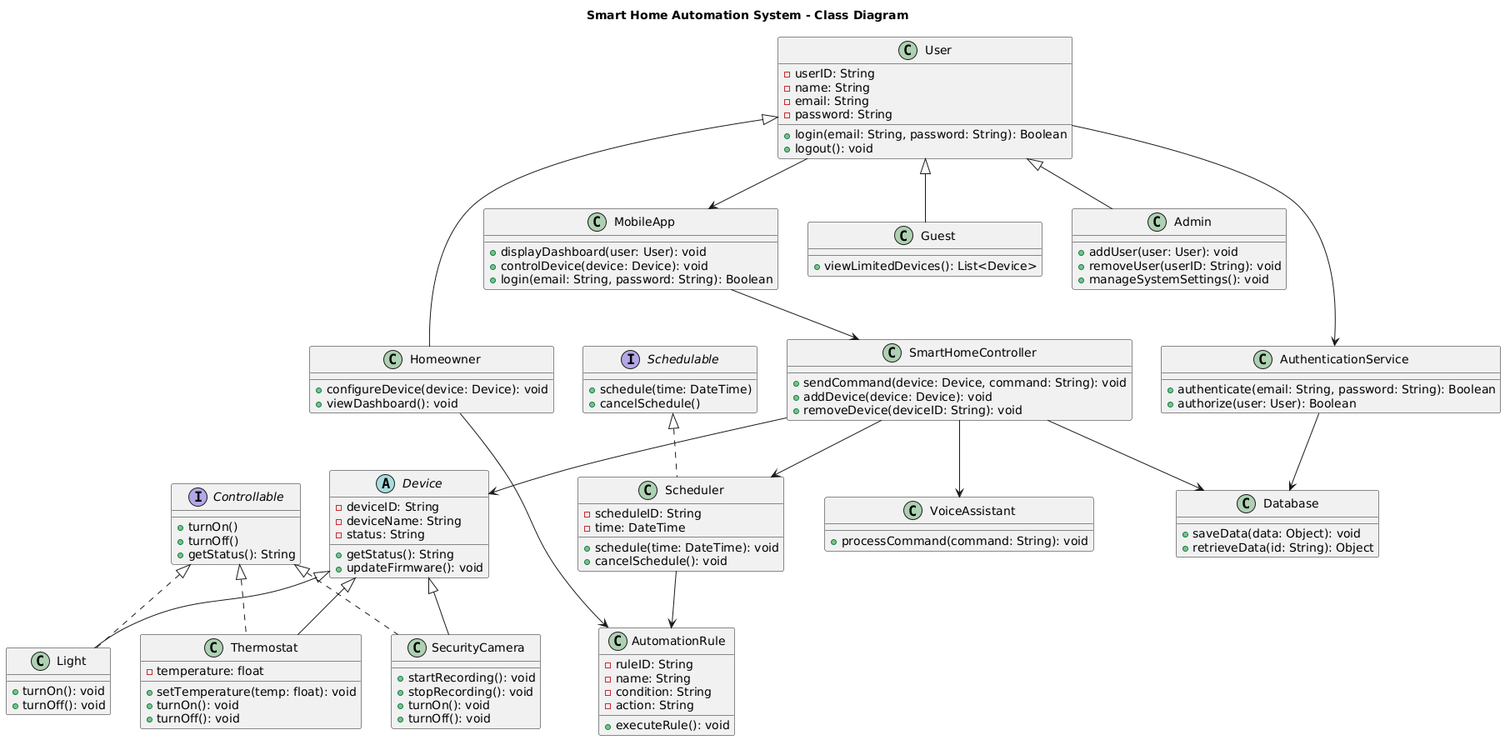

1. **UseCase Diagram:**

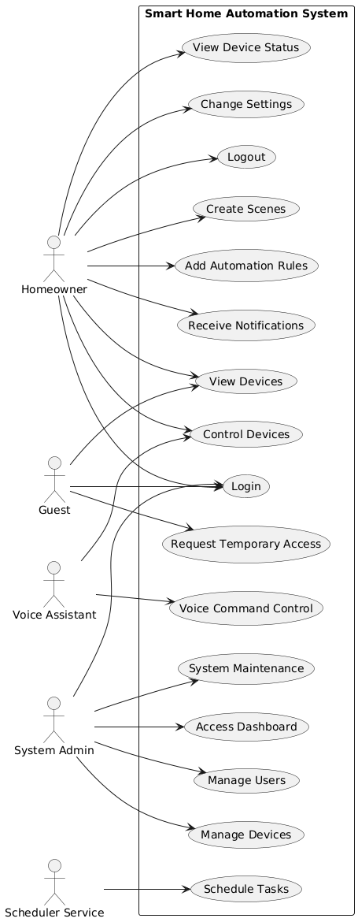

1. **Sequence Diagram:**

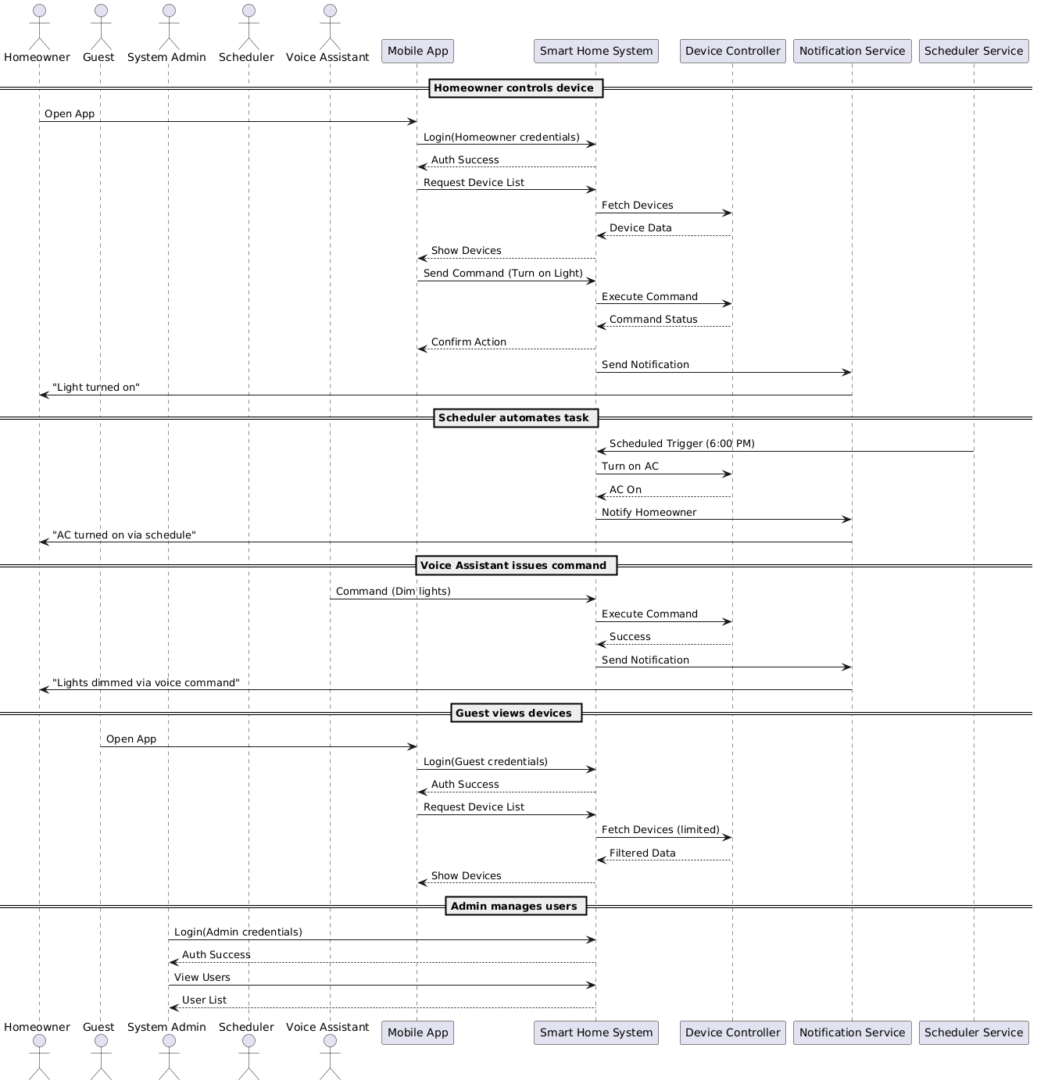

1. **ERD Diagram:**

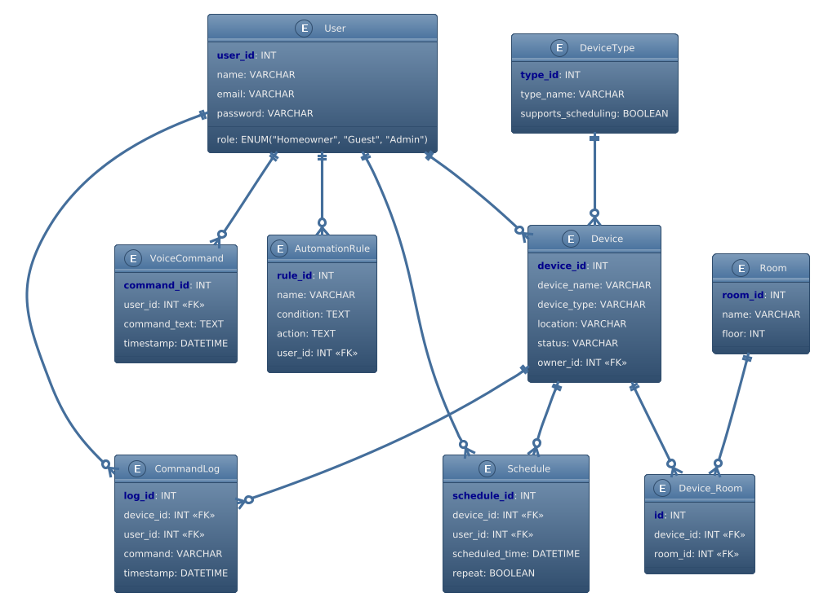

**6. Prototypes**

**Lo-fi Prototype:**

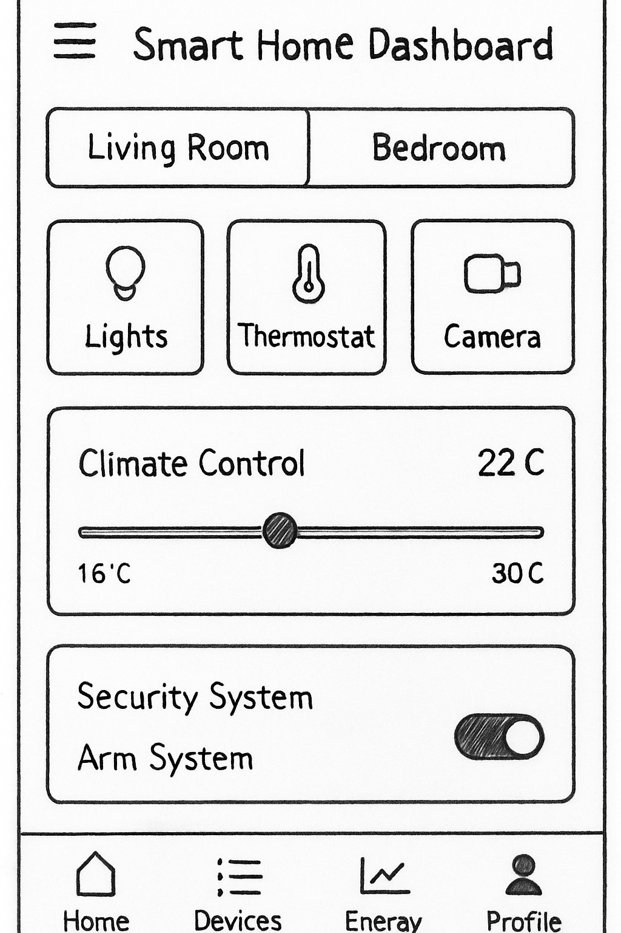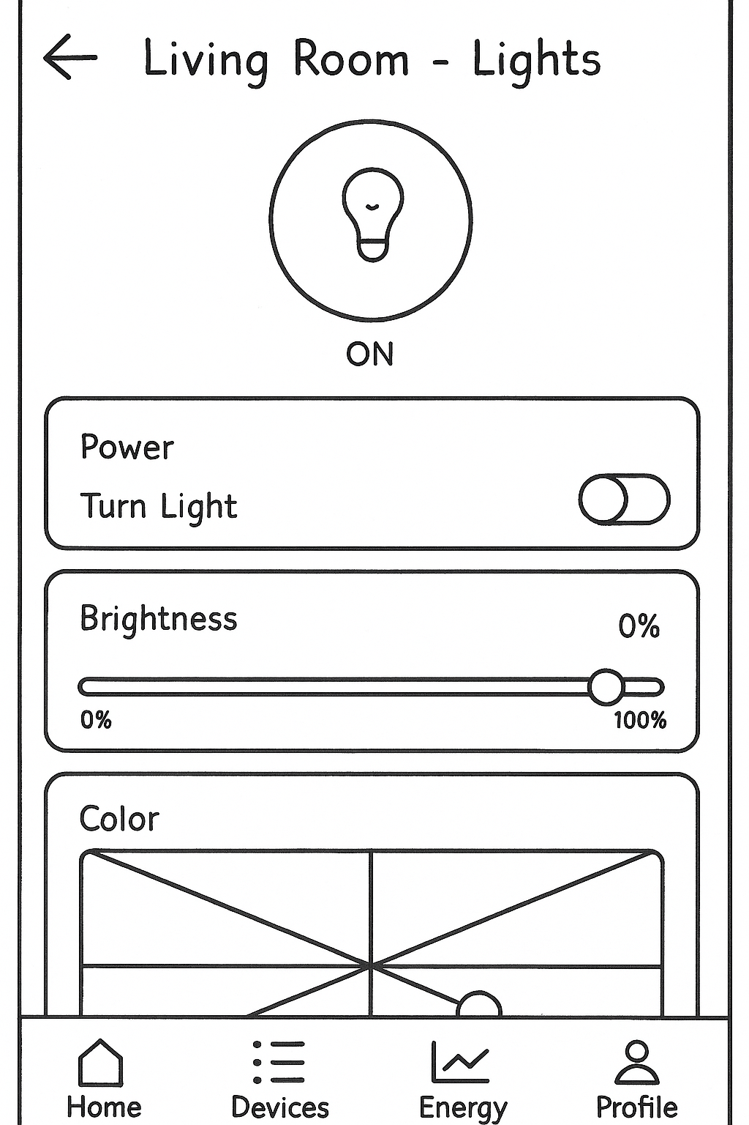

**Hi-fi Prototype:**

